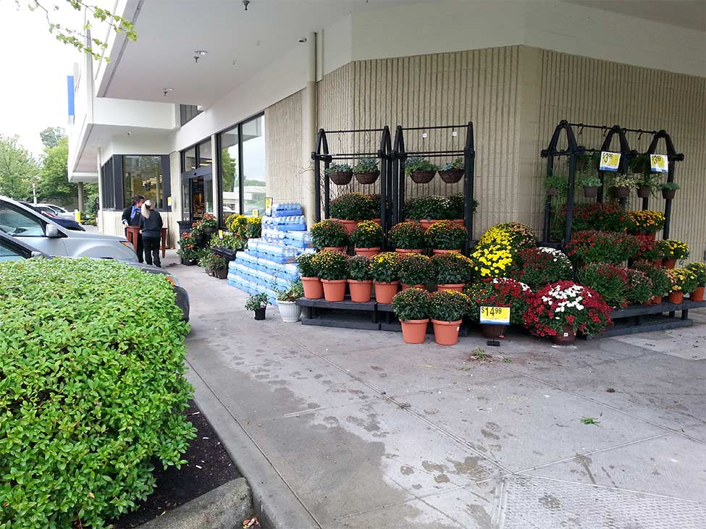
Let’s go to the market,
Let’s go right away
We can buy some cereal
And then we’ll go and play!

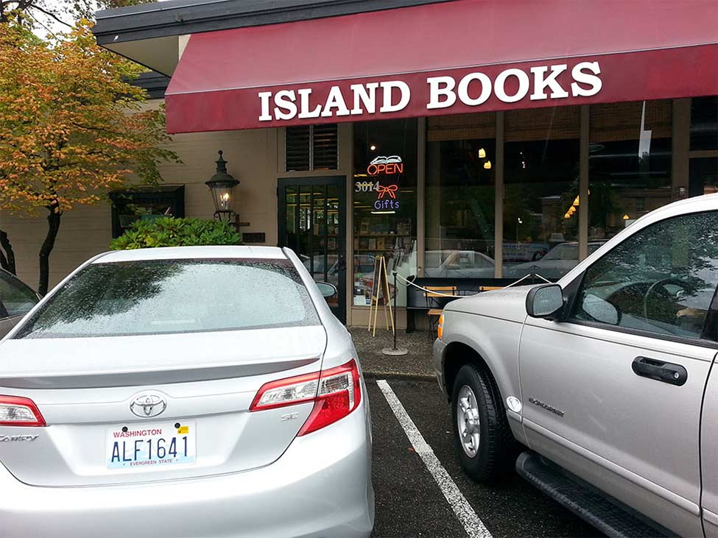

Let’s go to the book store,
Let’s go right away
We can buy some books to read
And then we’ll go and play!

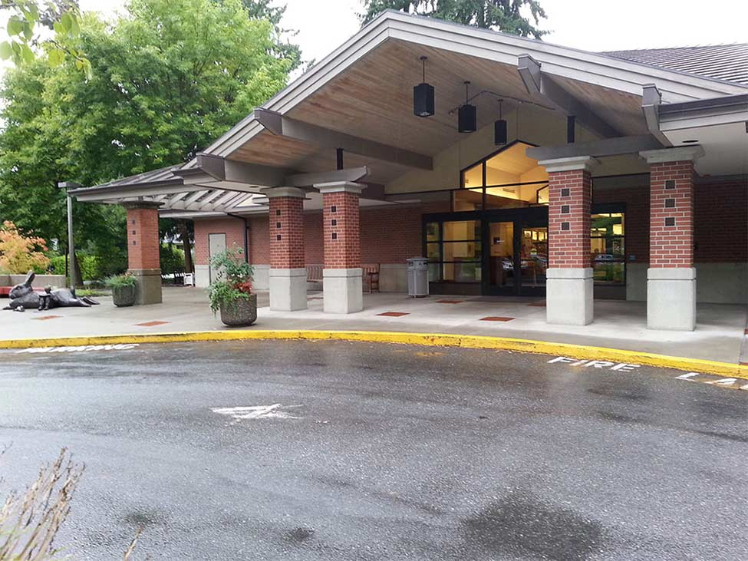
Let’s go to the library,
Let’s go right away
We can go check out some books
And then we’ll go and play!

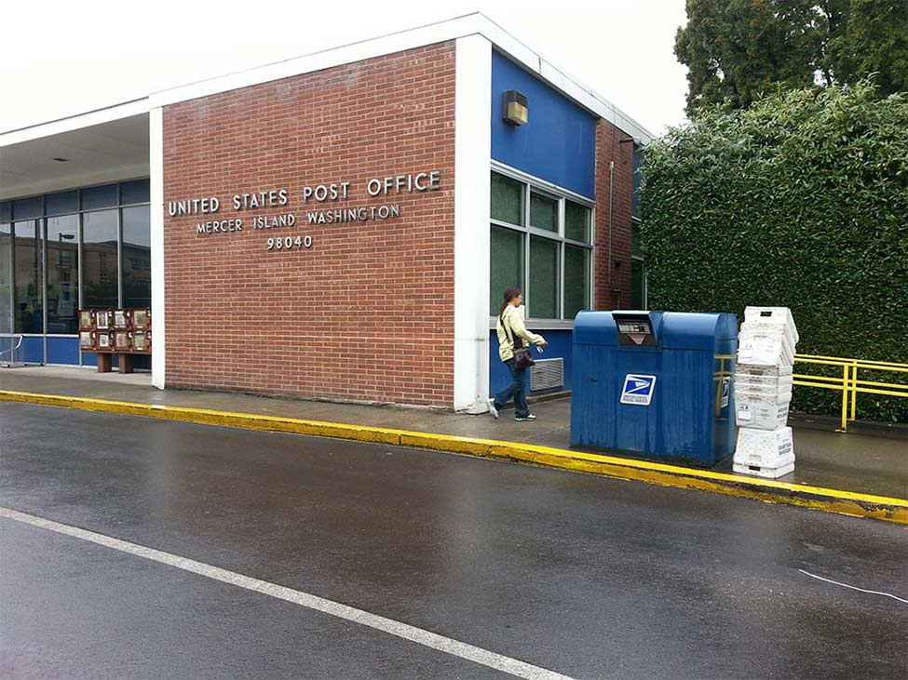
Let’s go to the post office,
Let’s go right away
We can mail some letters there
And then we’ll go and play!

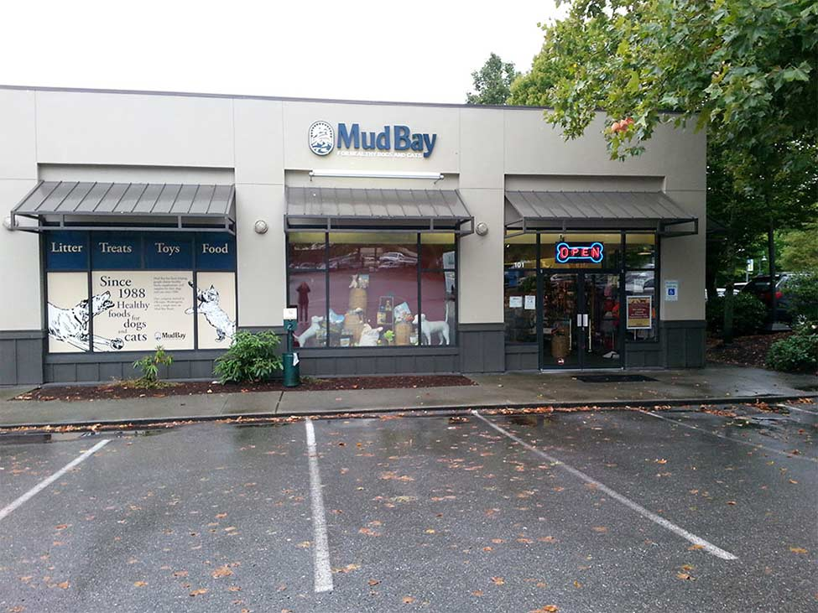
Let’s go to the pet store,
Let’s go right away
We can buy some dog food
And then we’ll go and play!

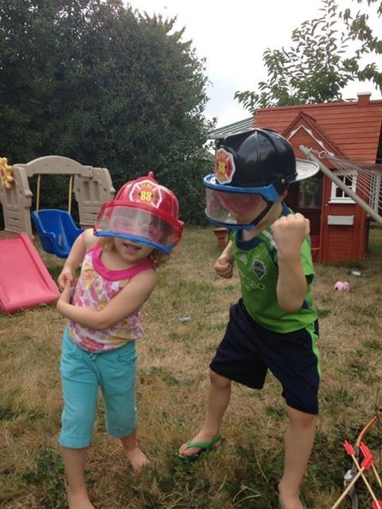

And now it’s time to play!

