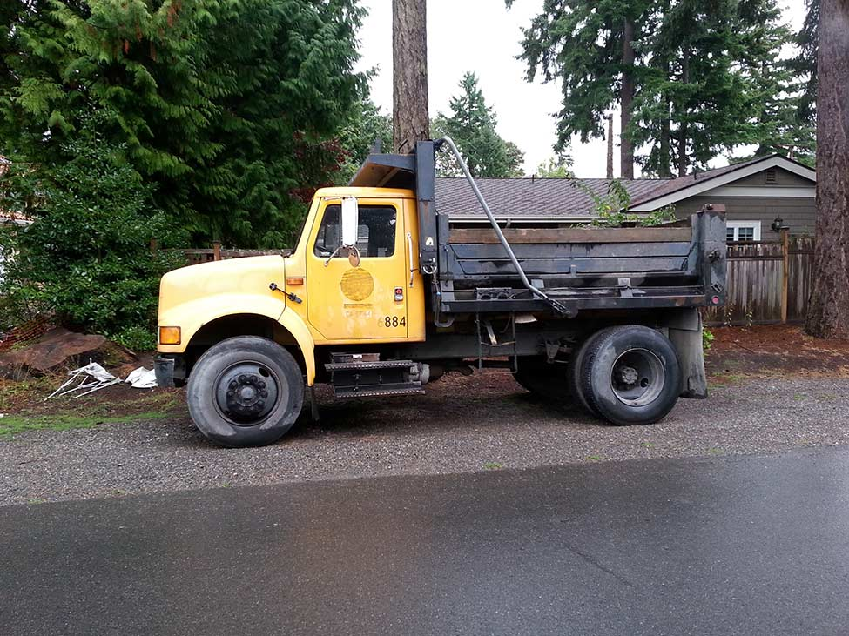

I’ll drive a dump truck,
Dump truck, dump truck
I’ll drive a dump truck
All day long

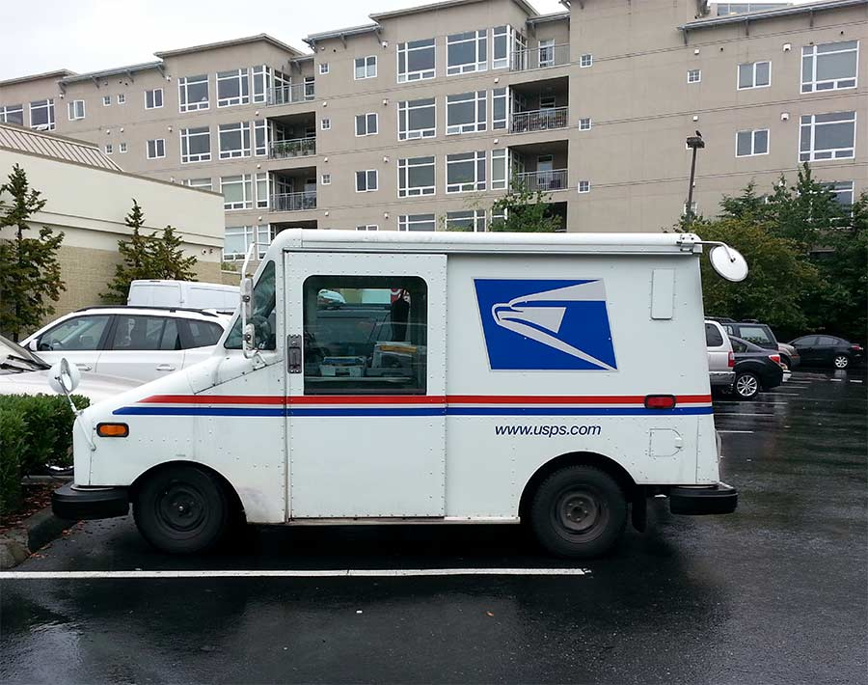

I’ll drive a mail truck,
Mail truck, mail truck
I’ll drive a mail truck
All day long

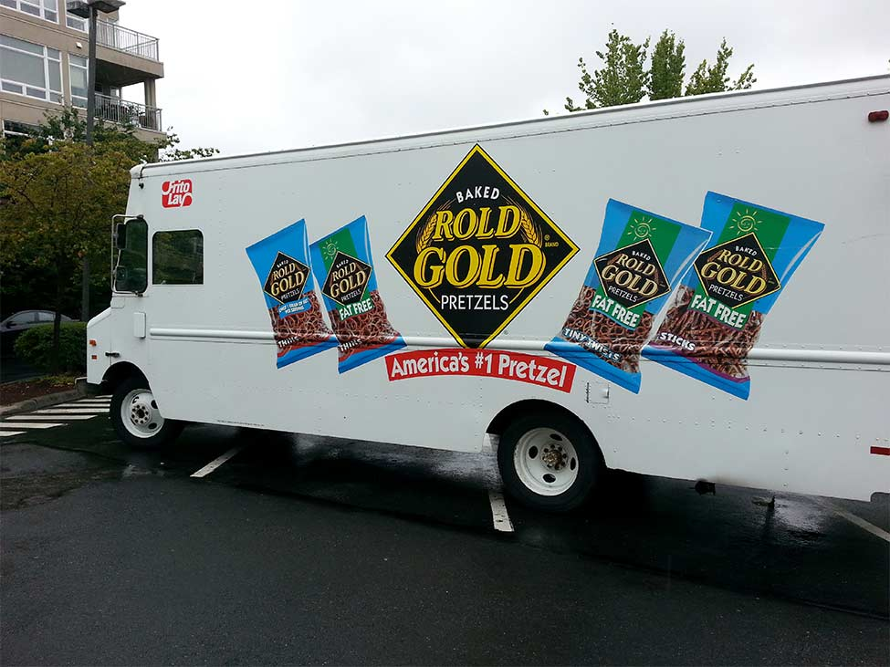

I’ll drive a pretzel truck,
Pretzel truck, pretzel truck
I’ll drive a pretzel truck
All day long

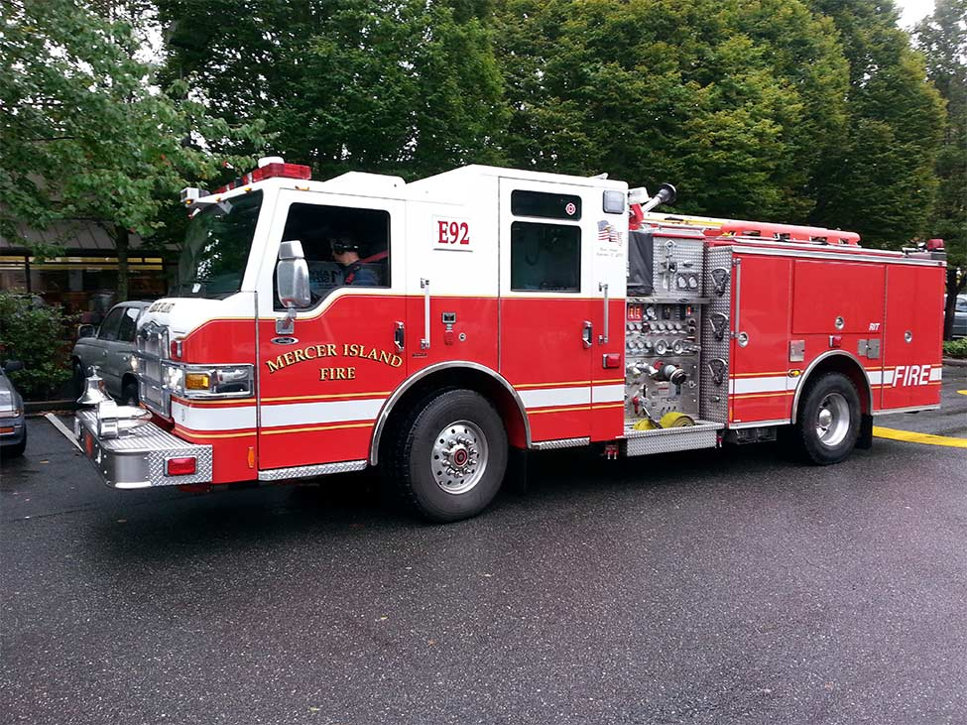

I’ll drive a fire truck,
Fire truck, fire truck
I’ll drive a fire truck
All day long

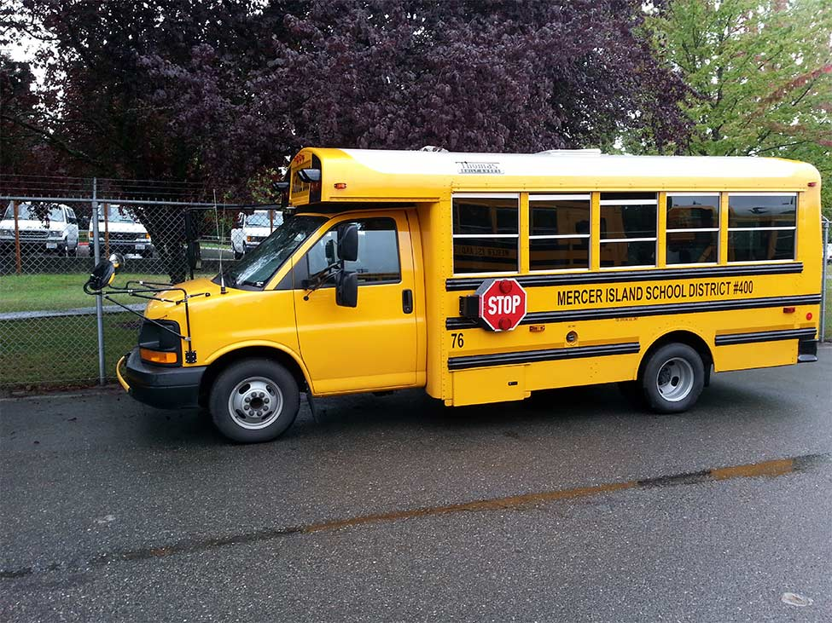

I’ll drive a school bus,
School bus, school bus
I’ll drive a school bus
All day long

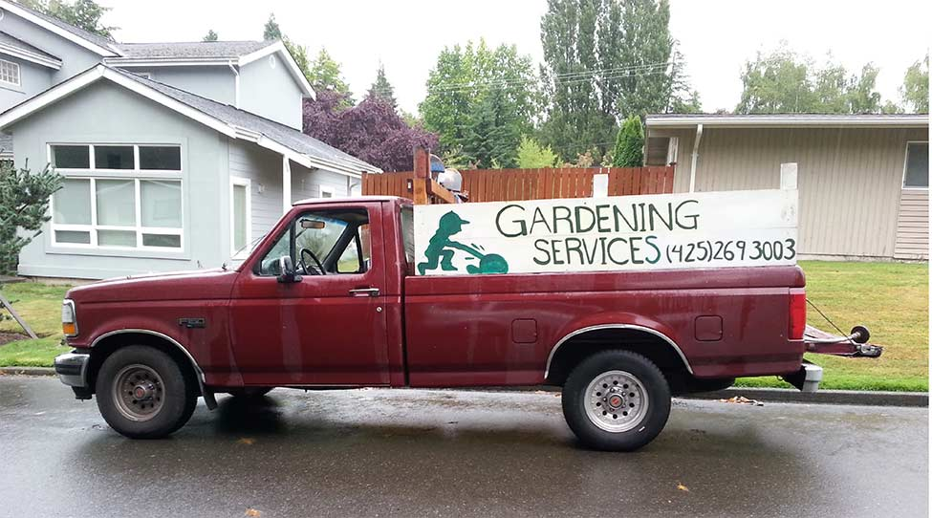

I’ll drive a gardener’s truck
Gardener’s truck, gardener’s truck
I’ll drive a gardener’s truck
All day long

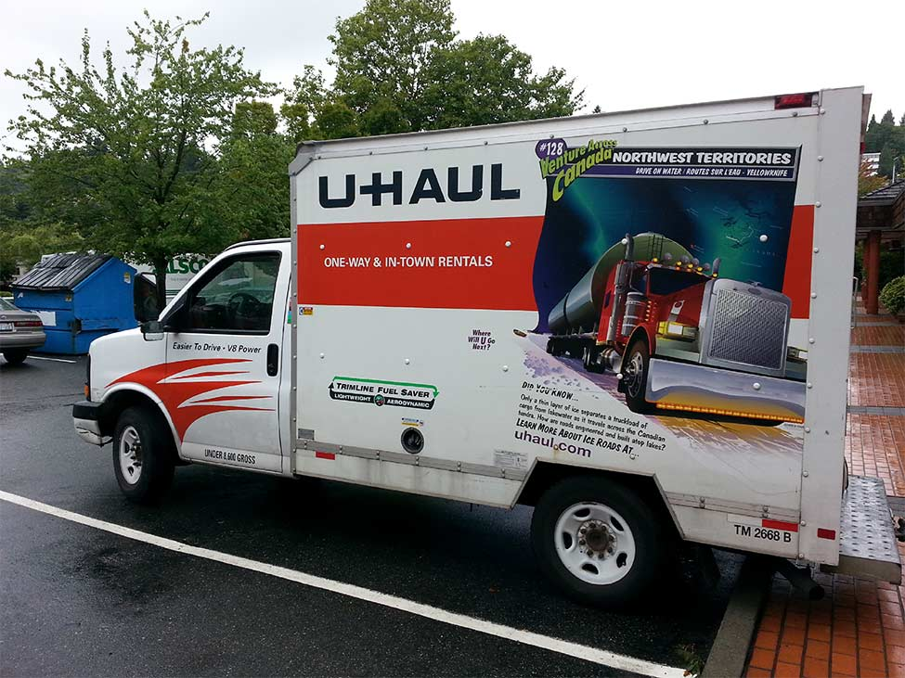

I’ll drive a U-Haul,
U-Haul, U-Haul
I’ll drive a U-Haul
all day long

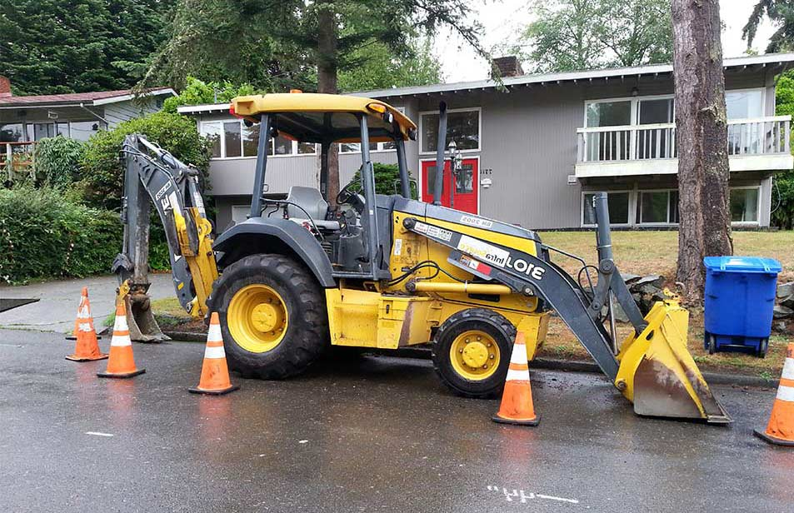

I’ll drive a backhoe,
Backhoe, backhoe
I’ll drive a backhoe
all day long

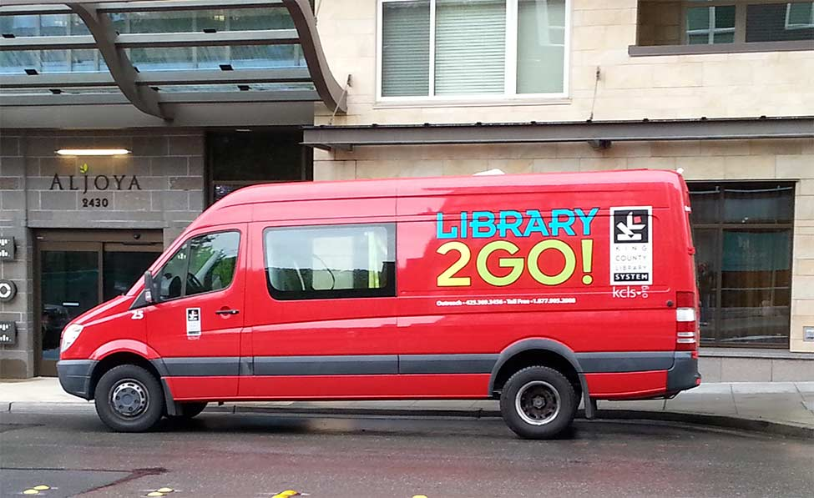

I’ll drive a library van,
Library van, library van
I’ll drive a library van
All day long

