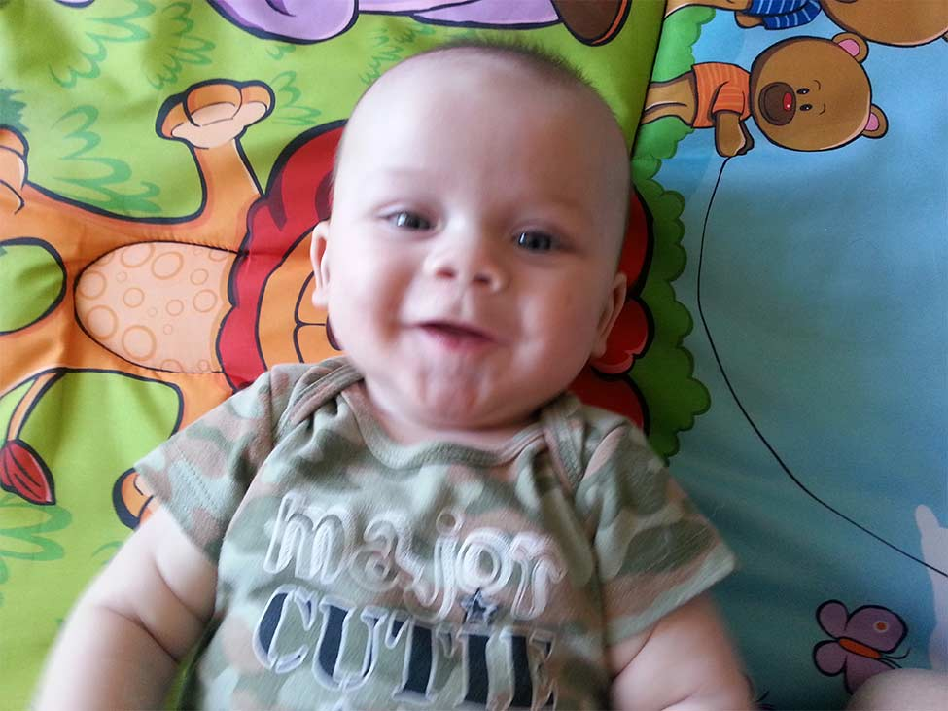
Baby, who do you see?
I see Jaxson looking at me.

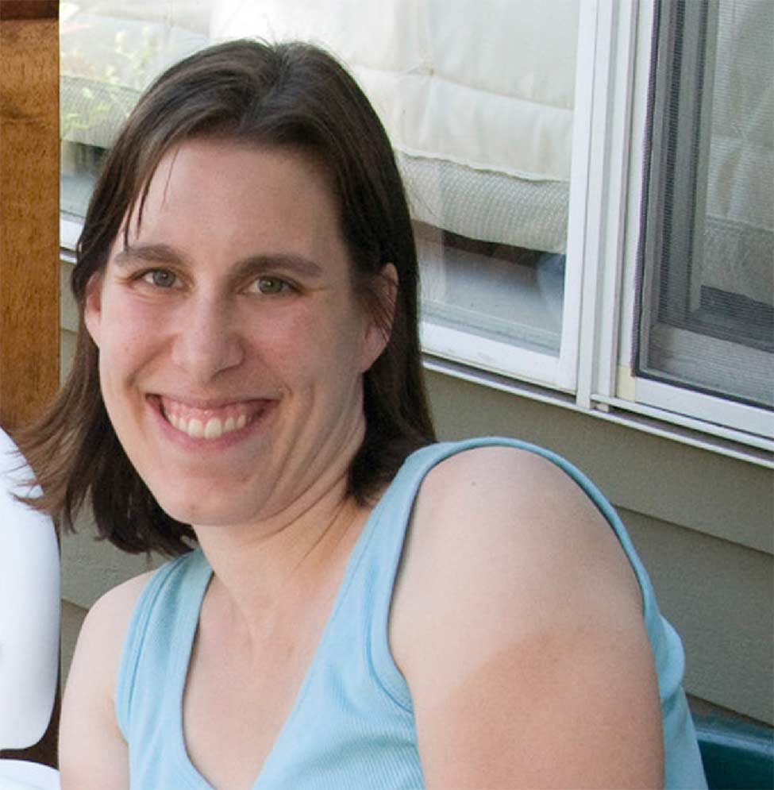
Baby, who do you see?
I see mommy looking at me


Baby, who do you see?
I see daddy looking at me


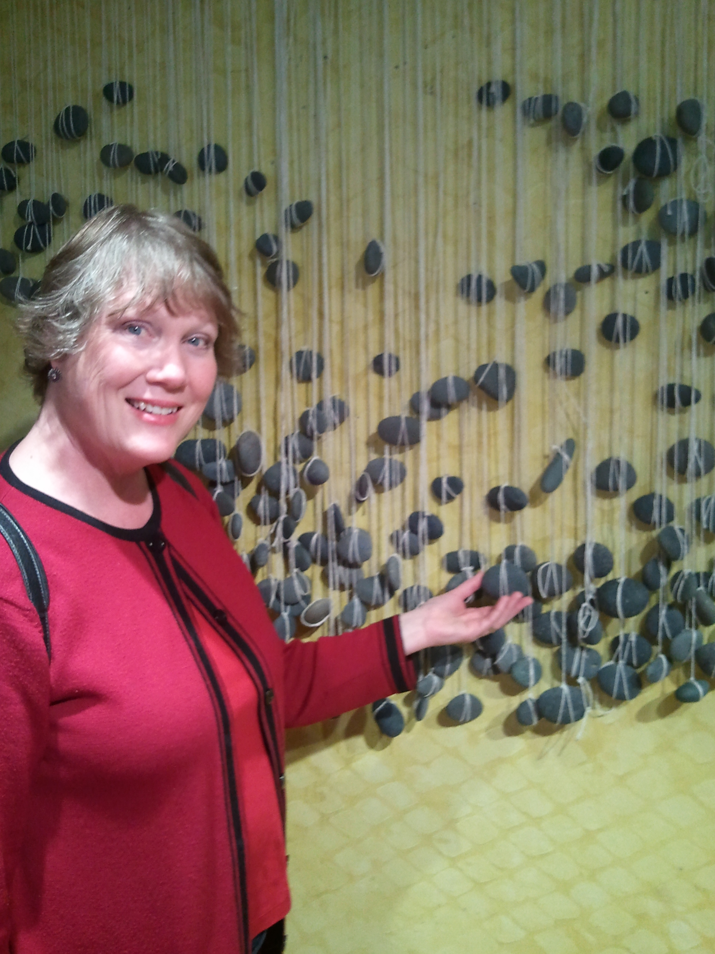

Baby, who do you see?
I see Grandma looking at me

Baby, who do you see?
I see Grandma looking at me
Baby, who do you see?
I see Grandma looking at me


Baby, who do you see?
I see Papa looking at me

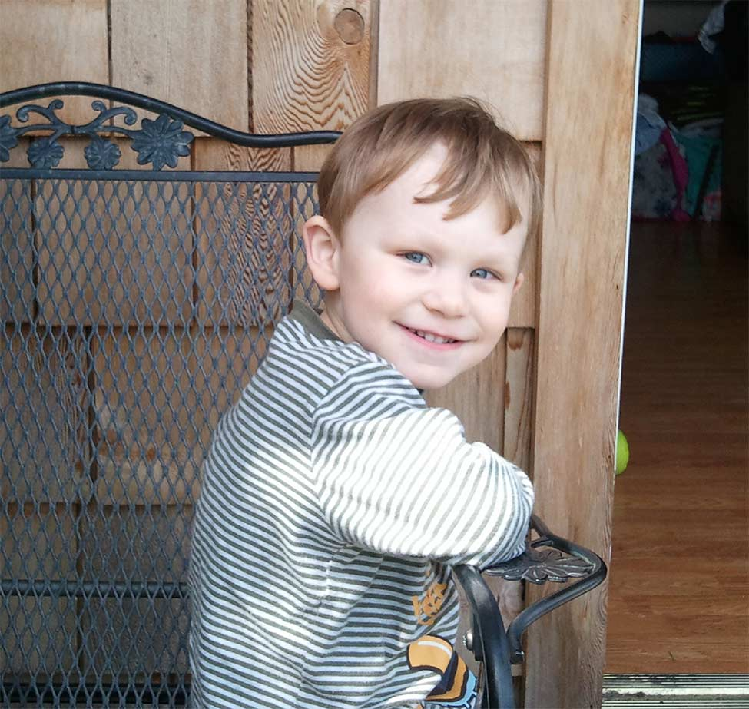
Baby, who do you see?
I see brother Jon looking at me

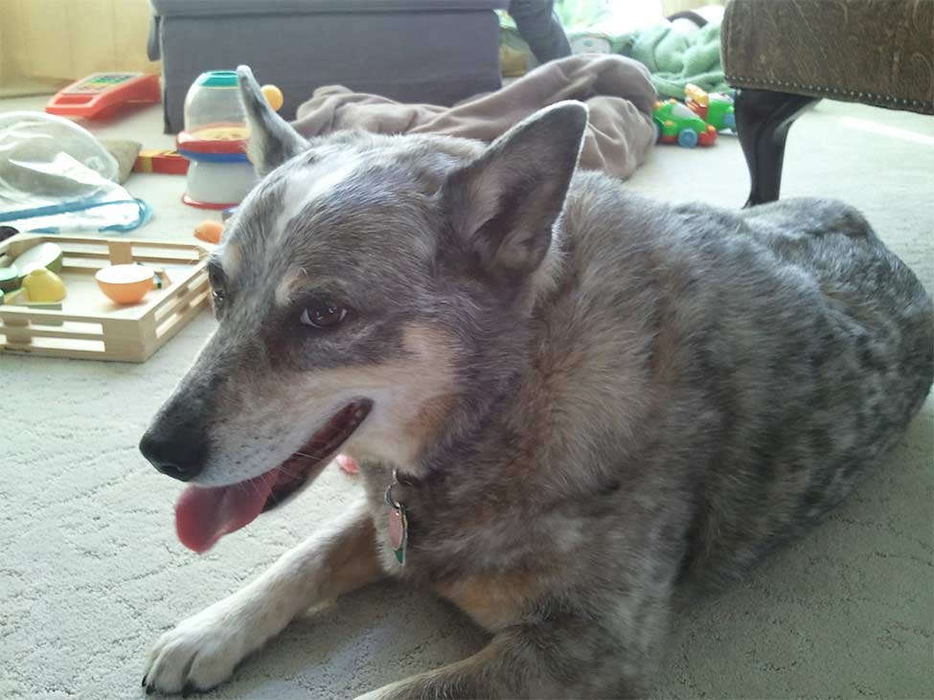

Baby, who do you see?
I see Jack Dog looking at me

